Module - 1
- What is SDLC?
- SDLC is a structure imposed on the development of a software product that defines the process for planning, implementation, testing, documentation, deployment and ongoing maintenance and support.
- A Software Development Life Cycle is essentially a series of steps, or phases that provide a model for the development and lifecycle management of an application or piece of software.

- What is software testing?
- Software testing is a process used to identify the correctness, completeness, and quality of developed computer software.
- Testing is the process of evaluating system or its components with the intent to find that whether it satisfies the specified requirements or not.
- ﻿﻿In simple words testing is executing a system in order to identify any gaps, errors or missing requirements in contrary to the actual desire or requirements.

- What is agile methodology?
- Agile SDLC model is combination of iterative and incremental model with focus on process adaptability and customer satisfaction by rapid delivery of working software product.

- What is SRS?
- A software requirements specification (SRS) is a complete description of the behavior of the system to be developed.
- ﻿﻿It includes set of use cases that describe all the interaction that the users will have with the software.

- What is OOPS?
- Identifying objects and assigning responsibilities to these objects.
- Objects communicate to other objects by sending messages.

- Write basic concepts if OOPS
- Object
- Class
- Encapsulation
- Inheritance
- Polymorphism
- Abstraction

- What is object?
- ﻿﻿An object represents an individual, identifiable item, unit or entity, either real or abstract, with a well -defined role in the problem domain.
- An object is anything to which concept applies.
- That is both data and function that operate on data are bundled as a unit called as object.

- What is class?
- Class defines a blueprint of an object.
- A class represents an abstraction of the object and abstracts the properties and behavior of that object.

- What is encapsulation?
- Encapsulation is the practice of including an object everything it needs hidden from other objects. The internal state is usually not accessible by other objects.

- What is inheritance?
- ﻿﻿Inheritance means that one class inherits the characteristics of another class. This is also called a "is a" relationship.
- As the name suggests Inheritance is the process of forming a new class from an existing class. Inheritance describes the relationship between two class. A class can get some of its characteristics from a parent class and then add unique features of its own.

- What is polymorphism?
- Polymorphism means "having many forms".
- ﻿﻿It allows different objects to respond to the same message in different ways, the response specific to the type of the object.
- ﻿﻿﻿Draw Use case on online bill payment system (paytm)

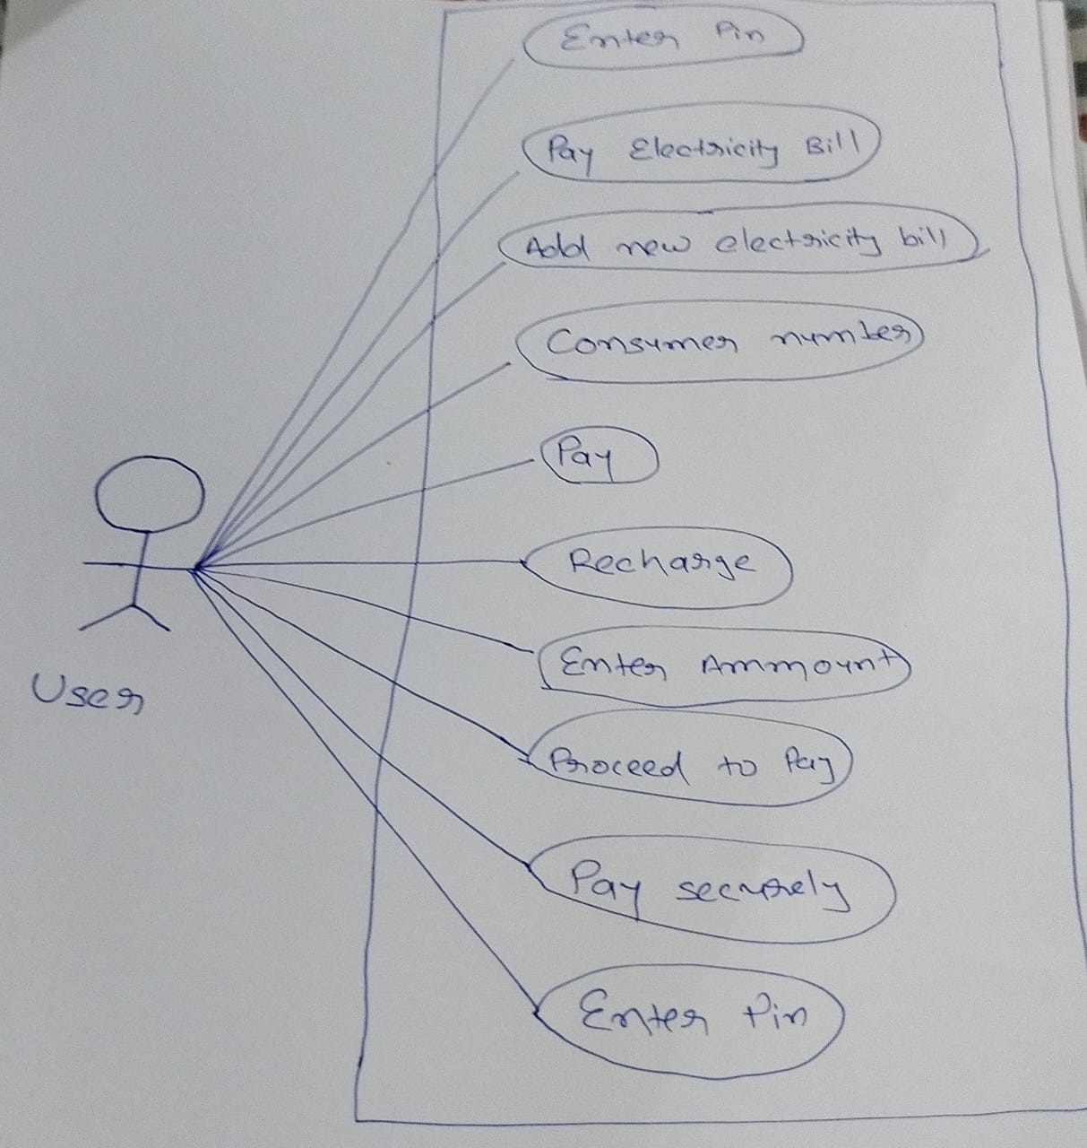

- ﻿Draw Use case on banking system for customers.

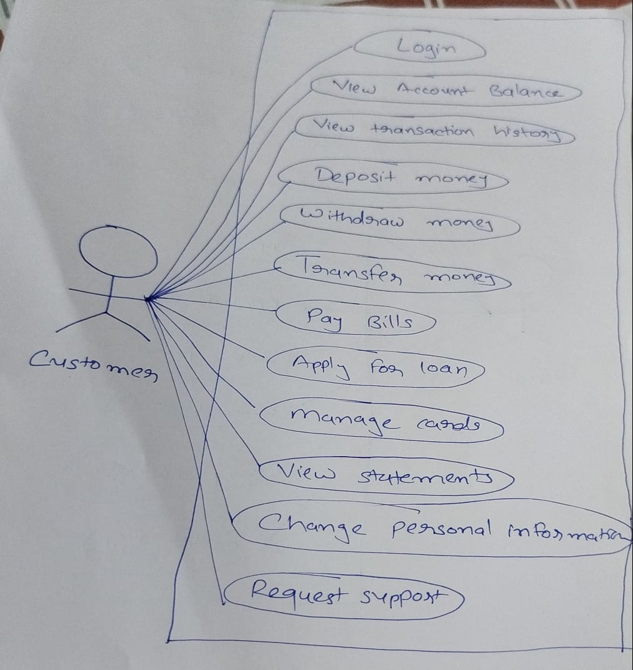

- Write SDLC phases with basic introduction.
- Requirements Gathering/ Collection - Establish customer needs
- ﻿﻿Analysis - Model and specify the requirements - "what"
- ﻿﻿Design - Model and specify the solution - "why"
- Implementation - Construct a solution n software
- Maintenance - Repair defects and adapt the solution to the new requirements.

- Explain phases of waterfall model.
- Requirement collection
- Analysis
- Design
- Implementation
- Testing
- Maintenance

- Write phases of spiral model.
- Planning - determination of objectives and constraints.
- Risk analysis - Analysis of alternatives and identification/ resolution of risks
- ﻿﻿Engineering - Development of the "next level" product
- Customer Evolution - Assessment of the results of engineering

- ﻿﻿﻿Write agile manifesto principles.
- Individual interaction
- Working software
- Customer collaboration
- Responding to change

- ﻿﻿﻿Explain working methodology of agile model and also write pros and cons.
- Working Methodology:
- Agile methods break the product into small incremental builds.
- These builds are provided in iterations.
- ﻿﻿Each iteration involves cross functional teams working simultaneously on various areas like planning, requirements analysis, design, coding, unit testing, and acceptance testing.
- At the end of the iteration a working product is displayed to the customer and important stakeholders.
- Pros:
- ﻿﻿Is a very realistic approach to software development
- Promotes teamwork and cross training ﻿﻿Functionality can be developed rapidly and demonstrated.
- Resource requirements are minimum.
- ﻿﻿Suitable for fixed or changing requirements.
- Delivers early partial working solution.
- ﻿﻿Good model for environments that change steadily.
- Minimal rules, documentation easily employed
- ﻿﻿Enables concurrent development and delivery within an overall planned context
- ﻿﻿Little or no planning required Easy to manage Gives flexibility to develops
- Cons:
- Not suitable for handling complex dependencies.
- More risk of sustainability, maintainability and extensibility.
- An overall plan, an agile leader and agile PM practice is a must without which it will not work.
- Strict delivery management dictates the scope, functionality to be delivered, and adjustments to meet the deadlines.
- Depends heavily on customer interaction, so if customer is not clear, team can be driven in the wrong direction.
- There is very high individual dependency, since there is minimum documentation generated.
- ﻿﻿Transfer of technology to new team members may be quite challenging due to lack of documentation use - case.

- Draw use case on OTT Platform.

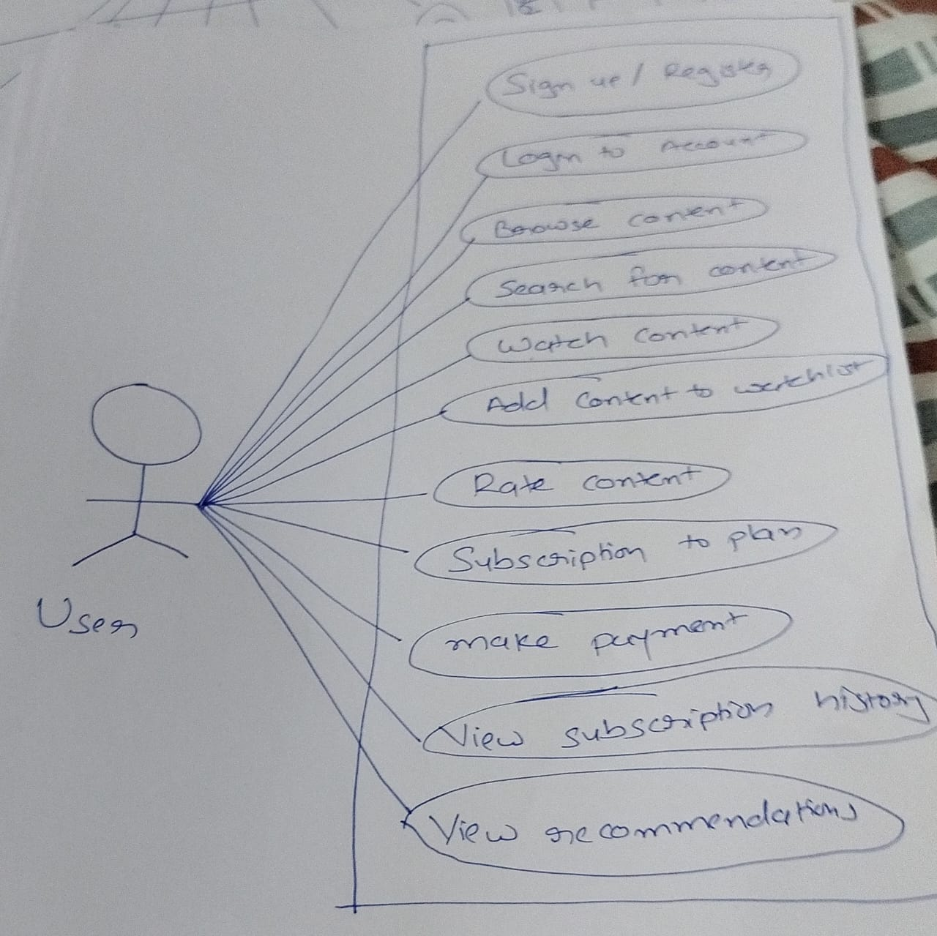

- Draw use case on E-commerce application.

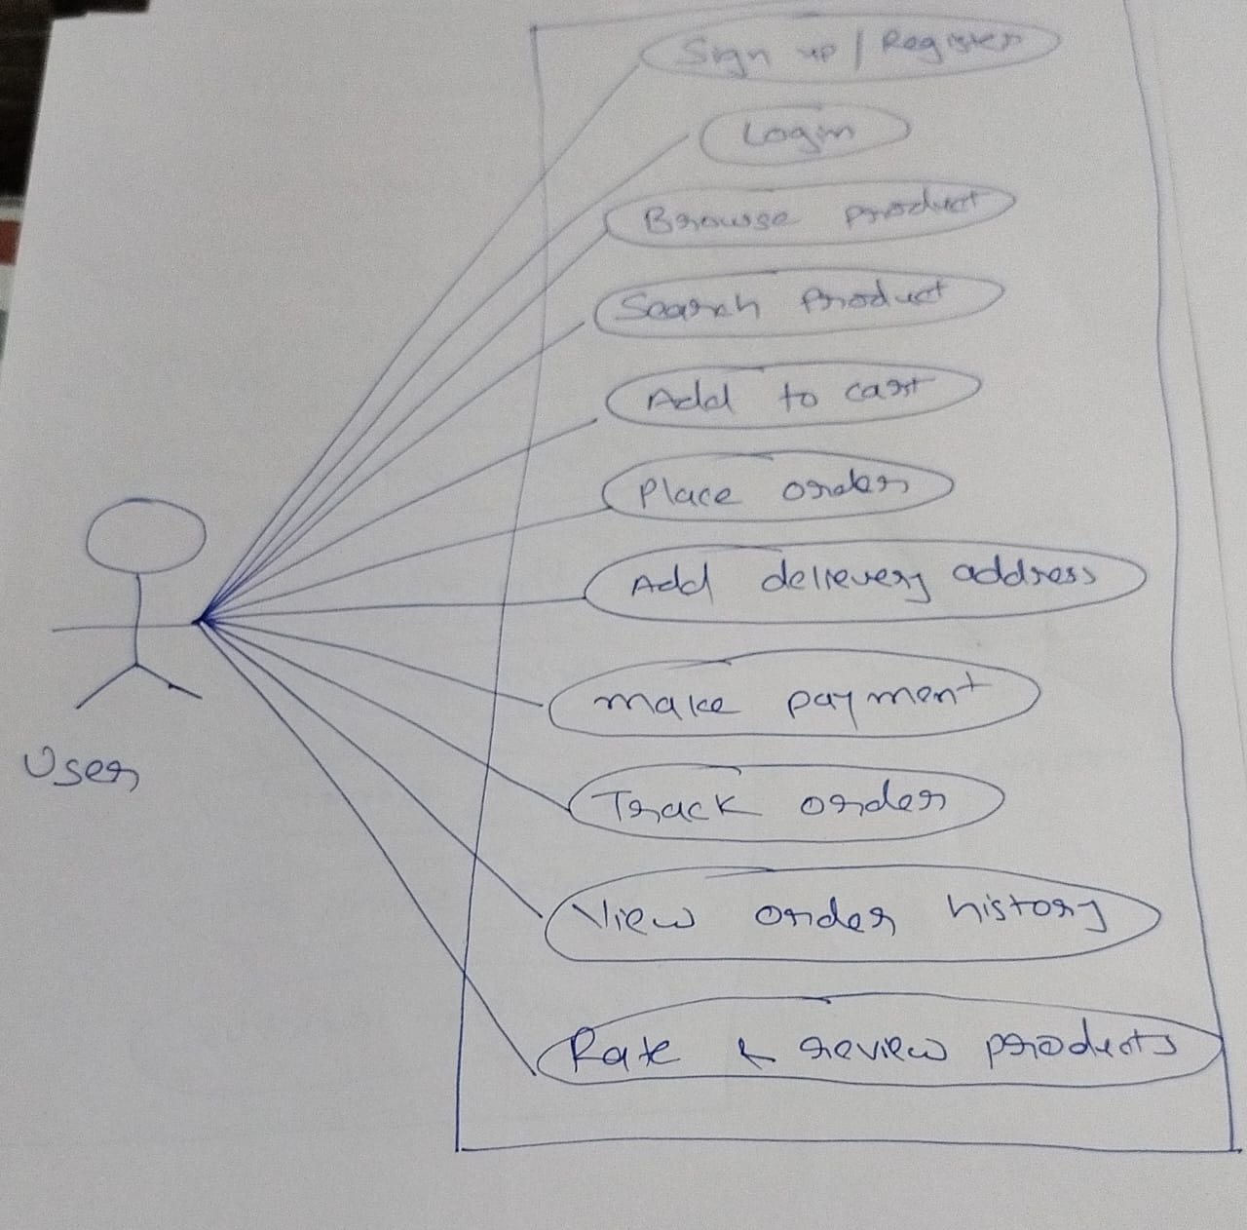

- Draw use case on Online shopping product using payment gateway.

